

Figure 1. Surface Wind Profile and Upper Wind Profile

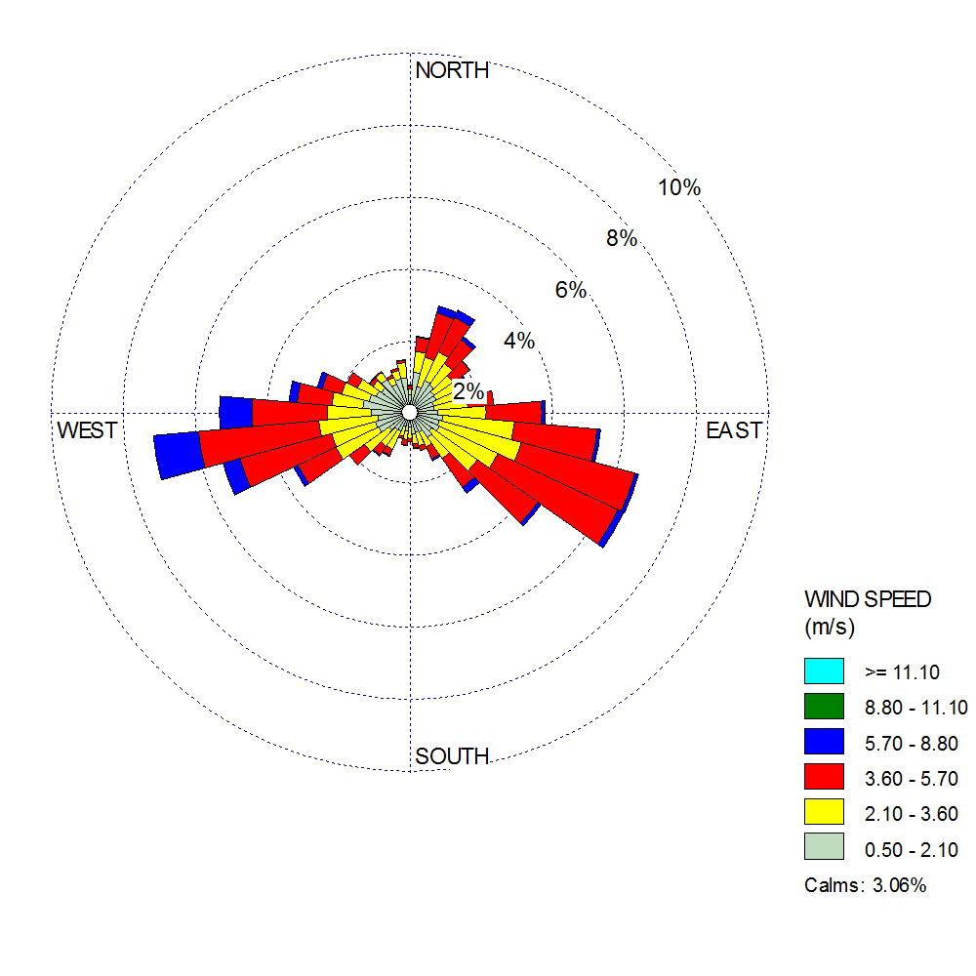

Figure 2. Radiosonde Wind Profile