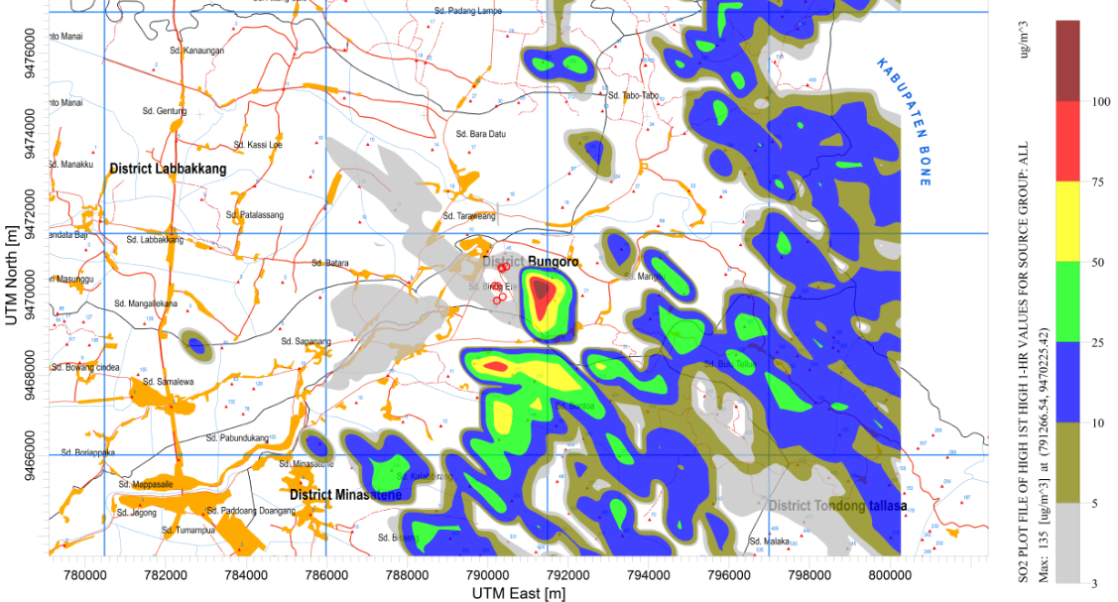
Figure 3. Dispersion Pattern of SO₂: Highest Hourly Average

