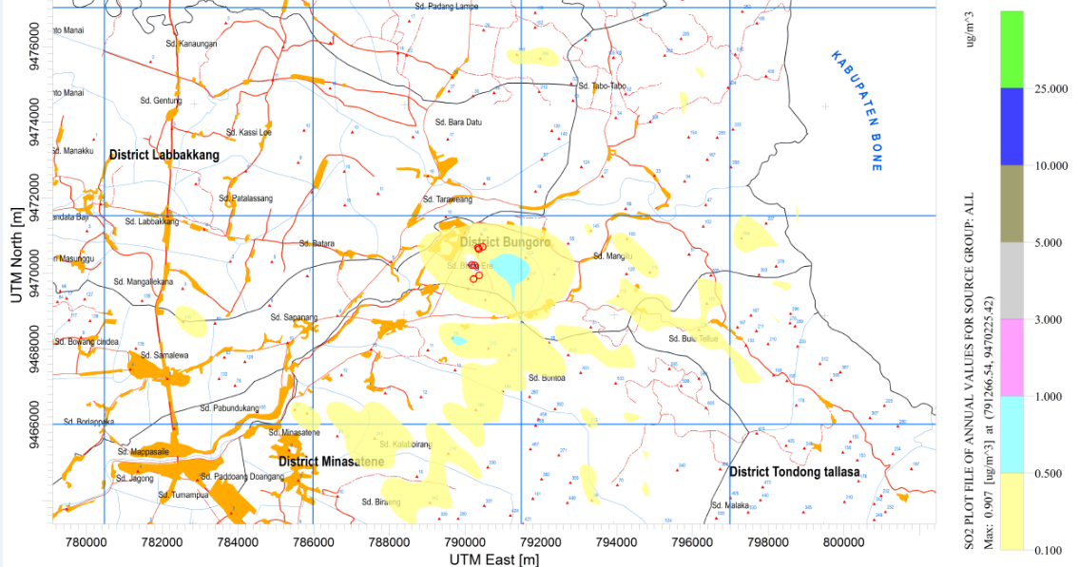
Figure 4. Dispersion Pattern of SO₂: Highest Annual Average

