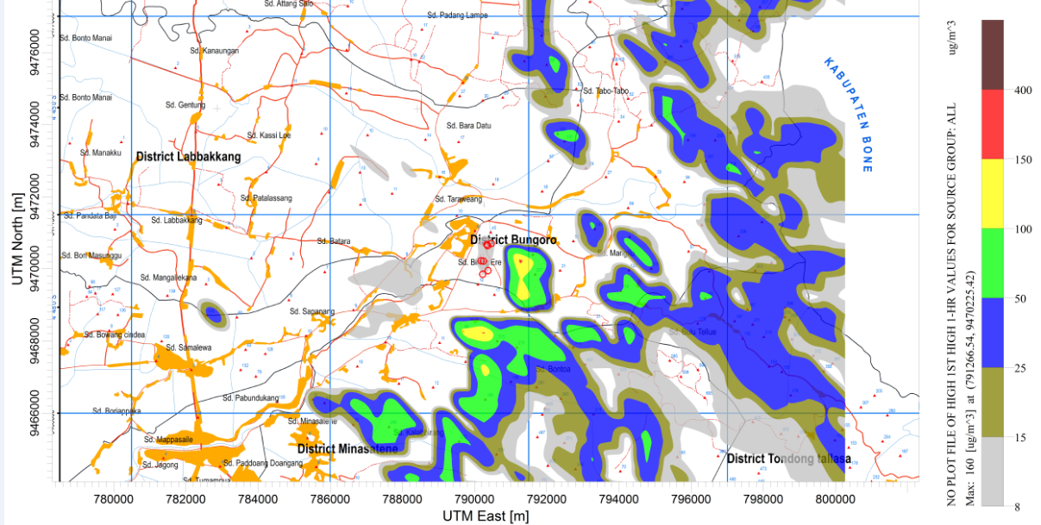
Figure 5. Dispersion Pattern of NO₂: Highest Hourly Average

