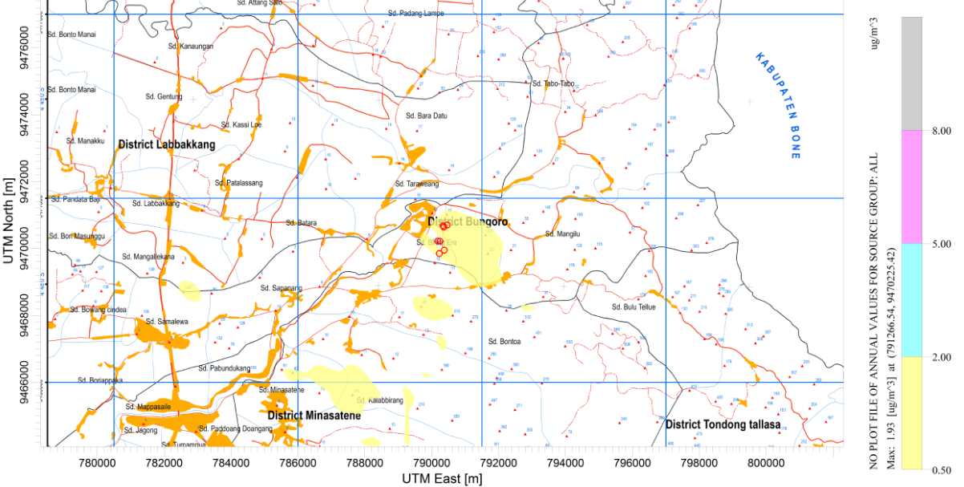
Figure 6. Dispersion Pattern of NO₂: Highest Annual Average

